**C:\Users\slobell\AppData\Local\Microsoft\Windows\Temporary Internet Files\Content.IE5\618TXVYP\MC900230029[1].wmfC:\Users\slobell\AppData\Local\Microsoft\Windows\Temporary Internet Files\Content.IE5\OJDIC3P2\MC900230027[1].wmfChop Chop**

SUWC

Love to cook *and* eat?

Join us for Chop Chop’s first event of the year**.**

**Apple Galette Workshop**

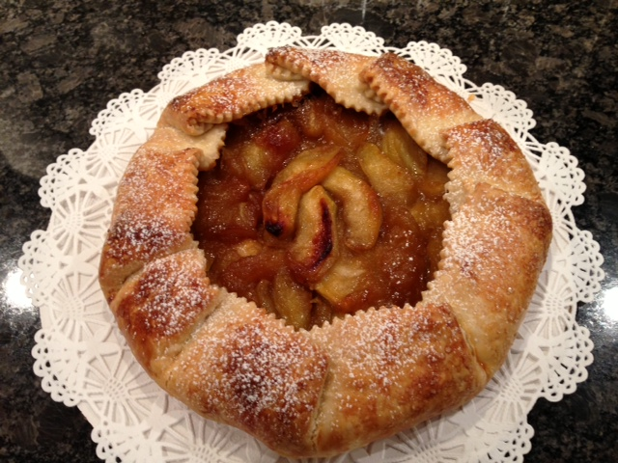

Come join other SUWC members and learn to make a simple and delicious Galette with caramelized apples. Everyone will create their own galette to take home and enjoy a tasty a galette made by Chef Toshiko Ueda [www.binkoueda.com](http://www.binkoueda.com" \t "_blank).

C:\Users\slobell\AppData\Local\Microsoft\Windows\Temporary Internet Files\Content.IE5\LHD3A59B\MC900371144[1].wmf

\*\*Please bring an apron and wear comfortable shoes.\*\*

**Date:** Wednesday, October 22

**Time:** 6:30 – 9:00 pm

**Place:** Bechtel International House Kitchen

**Fee:** $50 per person (*payment will be collected by chef at event*)

**RSVP by 10/17:** Meng Sui at [meng.sui@gmail.com](mailto:meng.sui@gmail.com" \t "_blank)

**Space is limited so reserve your spot soon!**